3/19/20
Staff who need to complete the DS 169 Child Abuse Mandatory Reporter training:

Name |  | Name
Beelman, Heather |  | Kamps, Donna
Bietz, Jackie |  | Kunde, Lori
Buckner, Valarie |  | Loring, Tina
Burnham, Jessica |  | Lutz, Kalisha
Cazin, Dawn |  | McCampbell, Melenda
Coppler, Michelle |  | Moeller, Robin
Dunlavey, Kelly |  | Morgan, Keli
Ewinger, Dave |  | Murphy, Rhonda
Ford, Larra |  | Myers, Julie
Franks, Jodie |  | Platt, Beverly
Garmoe, Linda |  | Rader, Peggy
Glendening, Gary |  | Rehm, Jennifer
Gonzalez, Gabriele |  | Reynolds, Brenda
Good, Daria |  | Rich, Mindy
Gound, Amy |  | Scott, Kathy
Grooms, Rebecca |  | Steele, Sandy
Hawley, Monte |  | Weldon, Diane
Irvin, Cheryl |  | White, Christy
Jacobs, Nancy |  | Williams, Penny
Kaltefleiter, Diann |  | Wrieden, Maria

You will need to access the following website through the CHROME web browser.
https://training.hs.iastate.edu/login/index.php .

Mandatory Reporter of Child Abuse Training

You have not accessed this website before so you will need to create an account.

Click create new account at the bottom.
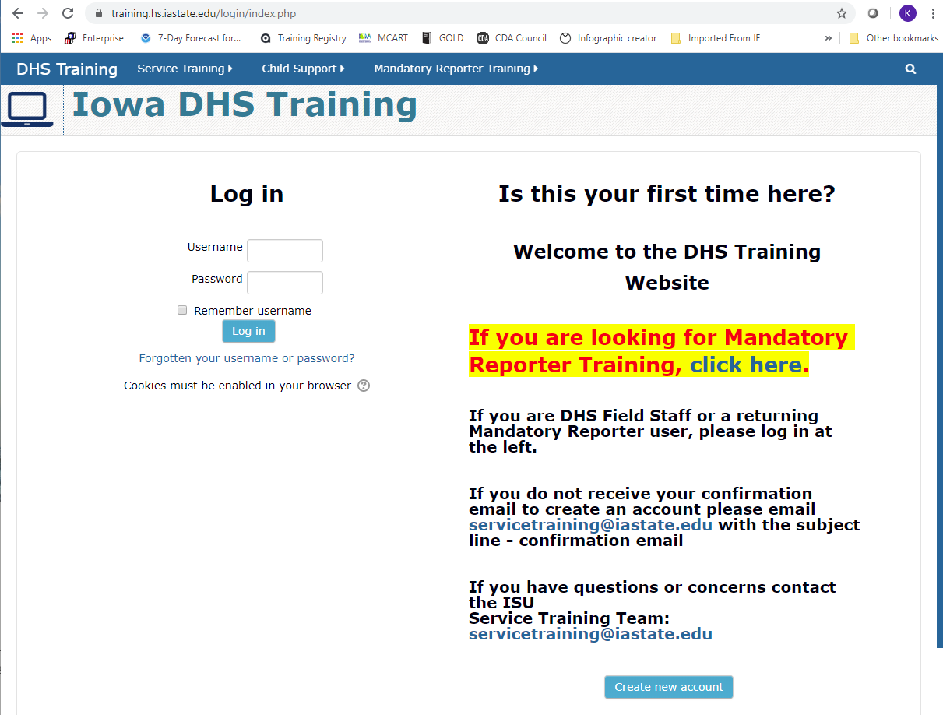

Fill in all required information.
**Note:
- Write down and save your username and password. You will need it again when you renew your training in 3 years.
- Use an email address that you have immediate access to.

At the bottom of the screen, click create my new account.
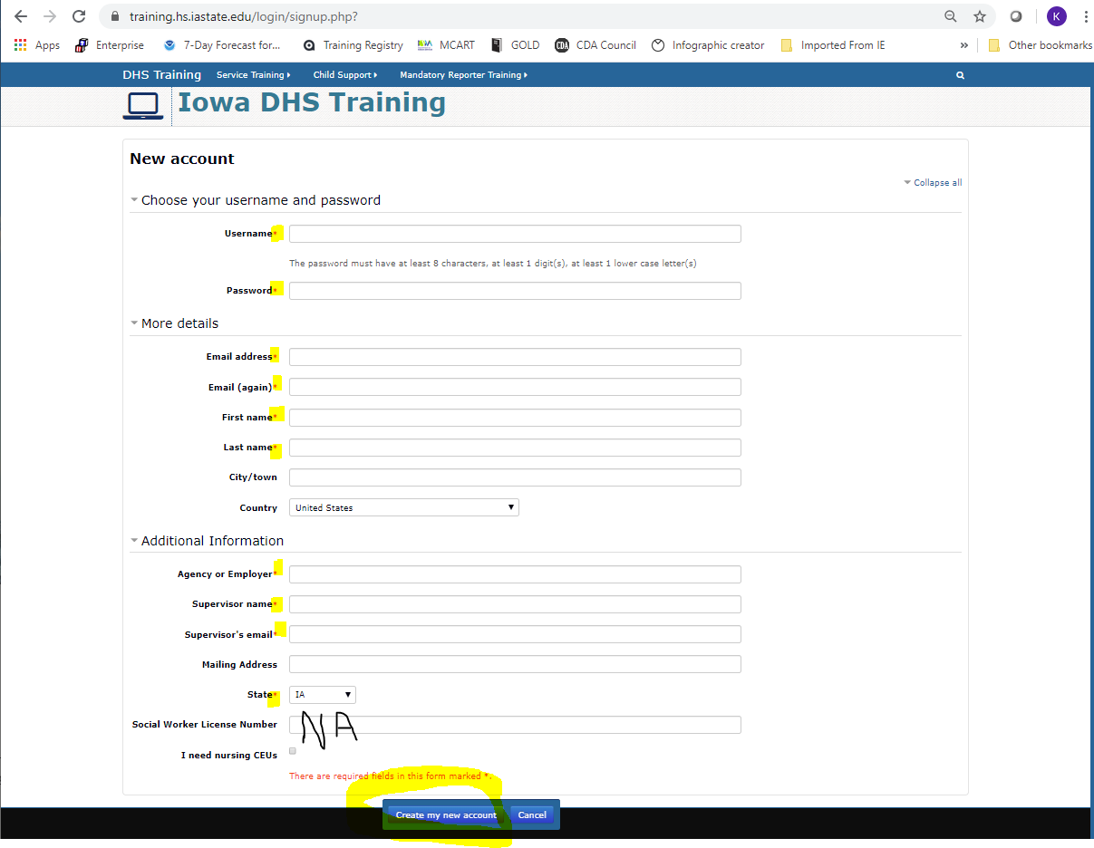

An email will be sent to the address that you provide. Please follow the link in that email to finish creating your account. Then log in to the system.

After logging in, choose the DS169 Child Abuse Mandatory Reporter Training option as shown below.

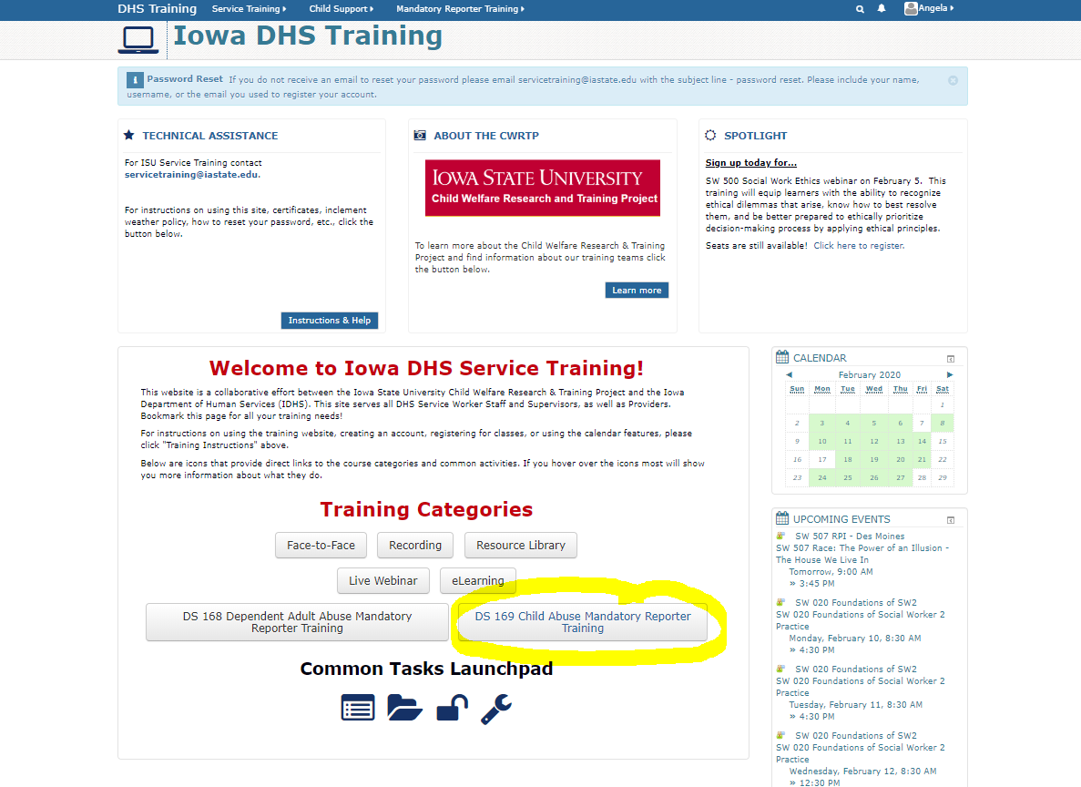

In order to successfully complete the training, you will need to complete the Pre-Test, Modules (lesson), Post-Test and Evaluation.
**Note: Please do not print the guide found under the Resources link as it is 84 pages. You may view it electronically. If you feel strongly that you need a copy, please request it from Kalisha as it is cheapest for us to print at Central Office. Alternatively, we will provide a condensed version of handouts.

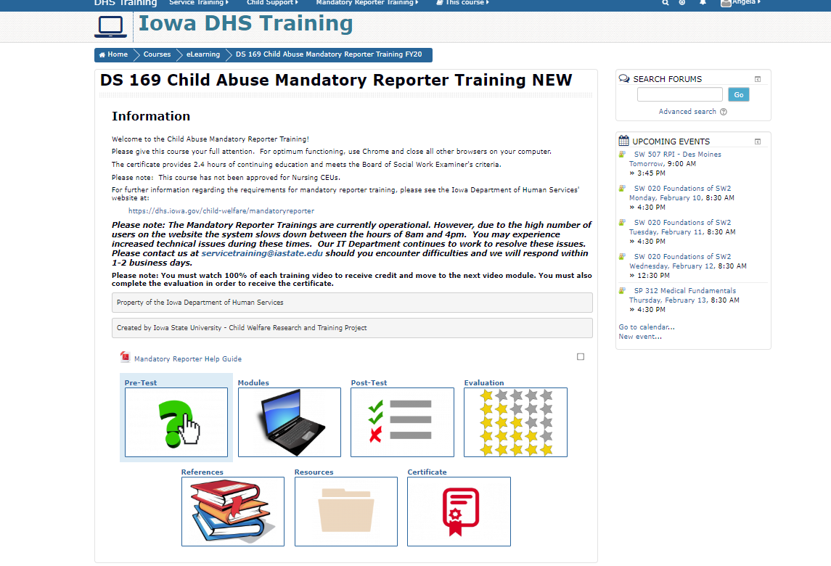

Once completed, please send a copy of your certificate to Kalisha at Central.
Record the time on your timesheet under training.

